SOFT351

Assignment 1

Joseph Kellaway

10503639

# Version Information

## Campus

Microsoft Visual Studio Professional 2015 – Version 14.0.25431.01 Update 3

DirectX SDK June 2010

## Home

Microsoft Visual Studio Enterprise 2015 – Version 14.0.25431.01 Update 3

DirectX SDK June 2010

# End User Guide

## Part 1

The user is presented with a 3rd person perspective of a winged-bear which they can move around the screen. The arrow keys are used to rotate the bear and alter the pitch that it is angled in. The W and S keys are used to move the bear forwards and backwards respectively. When turning at near maximum speed the bear will lean into the turn to mimic the animal shifting its weight. To prevent the user from losing the bear off-camera, the F4 key can be pressed to toggle a camera mode that follows the bear. The spacebar can be pressed to make the bear roar. The F1 key can be used to toggle whether these commands are shown on-screen whilst using the program. When angled skyward, the bear can use W and S to fly. Whilst flying the wings flap, a flapping sound is made periodically and the bear always leans whilst turning. If neither momentum key is pressed when flying, the bear glides whilst slowly losing momentum and falling to the ground. If the bear is angled towards the ground, it straightens upright when it lands.

## Part 2

The user is presented with a revolving pig. It is loaded from an “.obj” file and displayed on the screen. To change the pig to another shape, change the file loaded at line 494. To change the texture applied to the shape that is loaded, change the file loaded at 583.

# Programmer’s guide

## Part 1

Global variables that are relevant to all objects set up.

Thing3D - (eventually the floor, skybox etc will be instantiations of thing3d)

Bear created – Extends Thing3D with its own functionality

Bear turning – standard calculations

* Leaning
* Gimbal lock prevention

Bear movement – standard calculations

* Gravity
* Slow down

Skybox

Shadow

## Part 2

Load shape

Load mesh

Load material file

# Additional Notes to the Programmer

Currently, there is an is occasionally an exception thrown on startup of part 1. The exception declares that there is an access violation regarding memory location 0xFFFFFFFF and loads a line in

# Evaluation

# Appendices

## Appendix 1

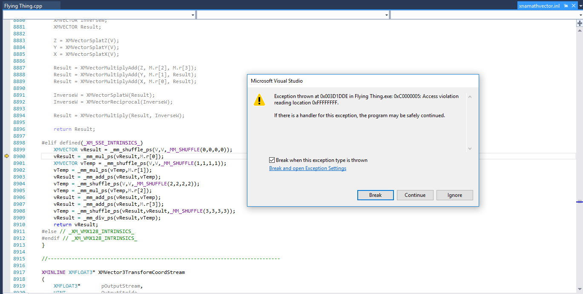

Occasional error on start-up of part 1.